How to answer: Will you now or in the future require sponsorship to work in the US
by Interstride

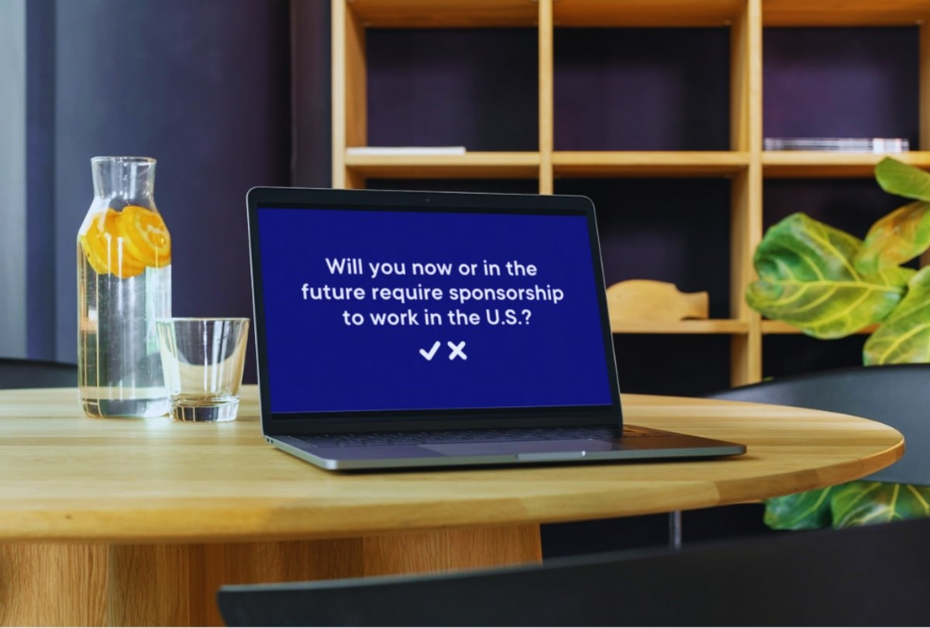
This is a question that US employers often ask on job applications. International students get very nervous about answering truthfully and fear that this will hurt their chances of getting the job. However, everyone should answer this question honestly and completely.
While international students will have authorization to work in the US for a period of time (e.g., OPT and CPT), it will eventually expire. International graduates will require a different work visa that will most likely require employer sponsorship. It’s important to practice strategic responses to the sponsorship question before you start applying for work in the US. You don’t want to fumble over your words or be dishonest on a job application.
Understanding the employer sponsorship question
These are the only questions that employers are legally allowed to ask you related to your immigration status:
- Are you legally authorized to work in the United States for any employer?
- Will you now or will you in the future require employment visa sponsorship?
Most job applications will include this question. They are standardized to prevent bias and discrimination, so you will usually encounter them worded in the same way. (Remember, employers cannot legally ask you for your nationality).
Employers have a right to know if you will need sponsorship. The sponsorship process comes with fees and extra paperwork, so some employers are unable to sponsor employees even if they want to. Companies may ask the question for a variety of reasons. Just because a company asks about sponsorship doesn’t tell you definitely whether they do or do not sponsor. Do your research on a company before applying to work for them. Take advantage of your international student network and reach out to alumni for informational interviews to learn about job opportunities and which companies hire international applicants.
Companies that have previously hired international student interns to full-time positions are likely open to sponsorship and already familiar with the process. Find the top companies that sponsor employees on Interstride’s blog. If a potential employer is unwilling to provide sponsorship, don’t get discouraged. It’s better to know up front than find out later in the interview process.
Factors to consider before answering
Before applying for jobs in the US, you should have a clear understanding of your long-term goals. This will help you accurately answer the work authorization question including the “in the future” portion. Ask yourself: Do you want to stay long-term in the US? If the answer is yes, then you will mostly need employer sponsorship in the future.
Research visa options for when your F-1 visa expires. Know your options before you start filling out job applications. What are the potential pathways to remain in the US?
OPT (on F-1 Visa) | H-1B Visa | O-1 Visa | TN Visa
Work authorization after graduation for up to 1 year or 3 years for STEM fields in a job related to your degree | Lasts up to 6 years but must win a lottery or work for a cap-exempt employer | Applicant must demonstrate a high level of achievement in sciences, arts, education, business, or athletics | Only for Canadian and Mexican citizens in certain occupations
Does not require sponsorship | Requires sponsorship | Requires sponsorship | Does not require sponsorship
Strategic approaches to answering the sponsorship question on an application
Here are tips from former international students and immigration experts about how to answer the sponsorship question when applying for work within the United States:
- Be honest and transparent in your response; don’t provide false information on job applications.
- Share your long-term career goals on the application and in the interview.
- “If you’re just filling out an application and answering this question and that’s it, you’re not going far enough. I think you need to reach out to a recruiter … and explain your situation.” – Aaron Blumberg in Demystifying the International Student Hiring Process by Interstride.
- Research employers’ policies on sponsorship and how this information can inform their response.
- Identify companies that are open to hiring international students and/or in-demand roles.
- Consult with an immigration attorney or designated school official for legal advice before your job interviews.
Sample answers to use in your interview
The best way to answer the sponsorship questions depends on your specific immigration circumstances and long-term goals. Use the examples below as a general guideline, but edit or customize them as desired.
Sponsorship Need: | Example Scenarios: | Sample Answers:
No immediate sponsorship required/Open to future sponsorship | Seeking an internship using CPT | “I’m authorized to work for this internship full-time over the summer and part-time during the academic semester, as long as it’s under 20 hours a week.”
 | Applying for an internship program where you know they will be offering full-time opportunities for some | “I am authorized to work for this internship up to 20 hours a week during the semester and full-time over the summer. After this internship/graduation, if I were to continue full-time, I will be authorized to work in the US for 1-3 years before I would need employer sponsorship.”
 | F-1 student eligible for STEM OPT extension | “I’m legally authorized to work in the US for 3 years. There is no cost to the employer and no need for sponsorship. If I were to continue with the company after 3 years, then I will need employer sponsorship at that time.”
Immediate sponsorship required | Your OPT has recently expired or will expire within the next month | “Yes, I need employer sponsorship to work within the United States. I am interested in the ___ visa but am open to other options (such as an H-1B visa, O-1 visa, or EB-2 green card).”
Future sponsorship required | OPT is expiring in the next few months | “I have work authorization through my current visa until ___ (state month and year that your visa expires). If you would like me to continue to work for your company after that time, I will need employer sponsorship.”
Confidently answer the employer sponsorship question on job applications
In most cases, international students and recent graduates should answer “yes” to the question: Will you now or in the future require sponsorship to work in the US? Even if you can work legally for several years on OPT or CPT, eventually your student visa will expire. Most work visas require employer sponsorship.
Many employers are open to sponsoring international applicants, so do not get discouraged by this question. Do your research ahead of time and answer confidently that you will need employer sponsorship in the future. Explore Interstride’s blog to find companies all over the country that are willing to sponsor international student graduates like you.

